Contents

A. Employee Self Service 1
1. Contact details 1
2. Diversity Configuration 1

Employee Self Service

Contact details

People Management > Data Centre > Reference Data

  - Use the toggle to enable or disable the options.

 | NB: Items can be selected to display without being updateable

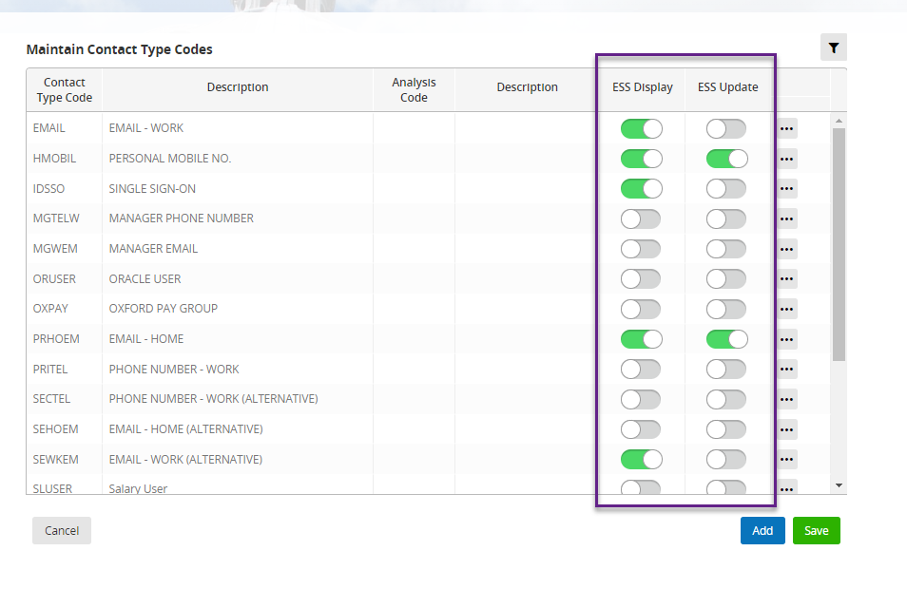

  - SAVE

Diversity configuration

People Management > Data Centre > HR Setup Settings > Diversity Config

  - Background details

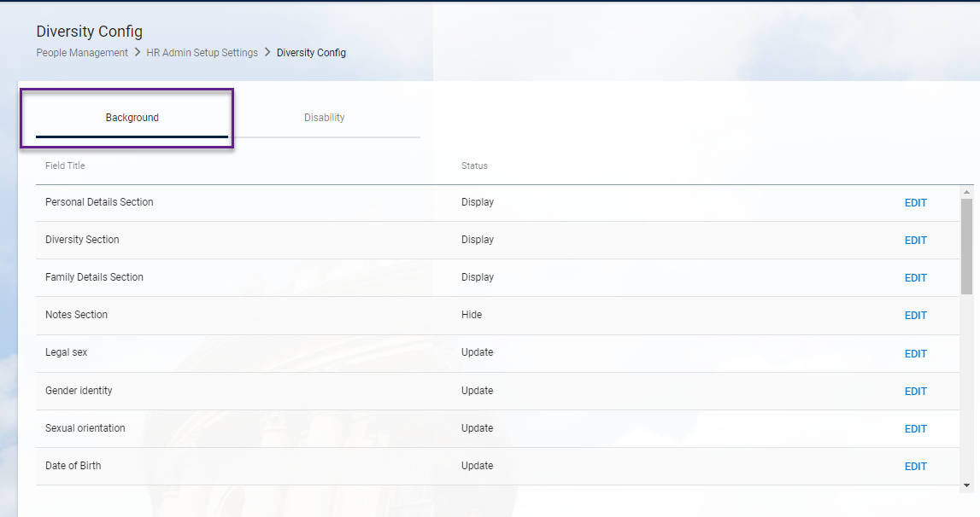

  - Disability details

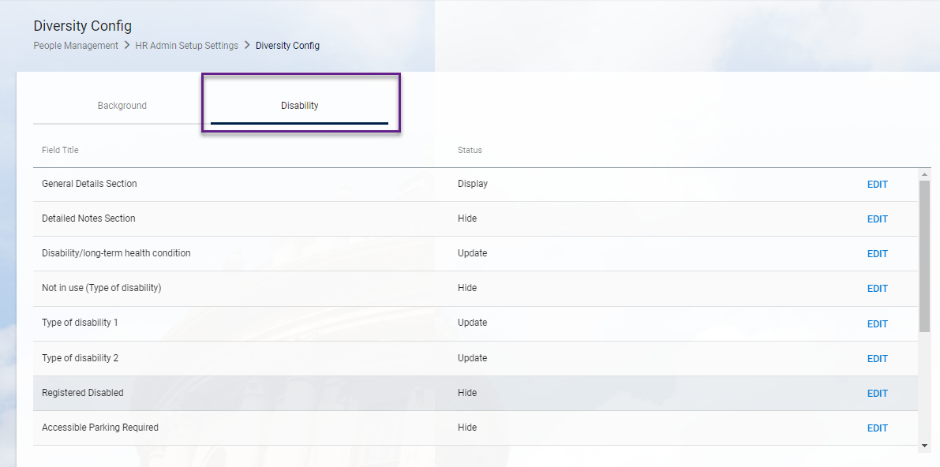

    - Click on EDIT against the item to change the options

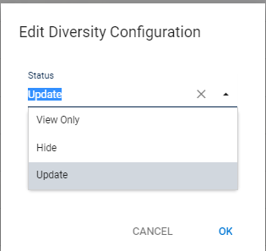

    - Then OK

Email notifications

There are some email notifications triggered when certain updates are made to an employee record – e.g. bank details. Also when an employee is made a leaver an email is sent reminding them to download their payslips and P60s. See the separate HOW TO guide for these.

Manager Self Service

Items configured to display in ESS should automatically become visible to the Manager via MSS

Knowledge Article: Employee self service

